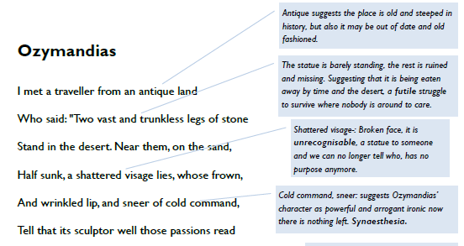

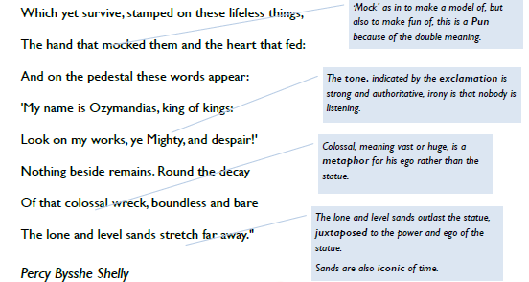

**London**

I wander through each chartered street,

Near where the chartered Thames does flow,

And mark in every face I meet

Marks of weakness, marks of woe.

In every cry of every man,

In every infant’s cry of fear,

In every voice, in every ban,

The mind-forged manacles I hear:

How the chimney-sweeper’s cry

Every black’ning church appalls,

And the hapless soldier’s sigh

Runs in blood down palace walls.

But most through midnight streets I hear

How the youthful harlot’s curse

Blasts the new-born infant’s tear,

And blights with plagues the marriage hearse.

WILLIAM BLAKE

**From ‘Songs of Innocence and Experience’**.

**Types of words:** make a list of words that fit into the categories below and comment on their effect on the reader.

**Negative Positive repeated**

Word effect

William Blake was a prolific English poet and artist who is considered to have made a very important contribution to the history of art and the Romantic movement, despite being largely unrecognised in his lifetime.

He produced some of the most memorable pieces of art and poetry ever created, and is widely remembered as ‘a man of extremes’ – his comments about his society were often rejected by his contemporaries and only valued by critics later. He was able to express social comment and philosophy through his creativity.

Much of Blake’s work reflects the influences of religion and revolution on eighteenth-century society. Although highly religious, he was critical of the Church of England and used some of his poems to pass comment and judgement on the role of the Church in society.

During the late eighteenth century the French Revolution was taking place, and a sense of uprising against authority (the monarchy and the Church) was spreading. In 1792 (when ‘London’was written) revolutionary mobs were invading Paris to overthrow the king. Blake openly supported this rebellion, and despite the government putting in place a law to outlaw writings of a disloyal nature, Blake still manages to reveal his discontent through the negative voice that he uses so well in ‘London’.

**Why does Blake use four stanzas?**

**Stanza 1:** The narrator is walking through the streets of London, he comments that all of the streets and the river Thames are *“chartered”,* this means owned by the government. He *“marks”* **(meaning observes)** lots of people in the streets, all with *“marks”* **(meaning expressions)** of sadness or *“weakness”.*

**Stanza 2:** This stanza shifts from what the speaker sees to what he hears. These sounds suggest that the misery of the city affects everyone: the people themselves are trapped by their own attitudes: *“mind forged manacles”.*

**Stanza 3:** The speaker now focuses on the institutions he holds responsible for the state of the city. He singles out the powerful church and state who could do something but don’t.

**Stanza 4:**This stanza returns to focus on people and the effect of the corruption on them, even on new-born babies. Nothing pure remains.

This is a **dramatic monologue** – the **first person** narrator speaks about the suffering he himself sees. The **ABAB rhyme scheme** is unbroken and seems to echo the relentless misery of the city. The regular **rhythm** could also reflect the sound of his footsteps as he walks.

The rhyme and rhythm of the poem is reinforced by the use of **repetition**. Notice how many words appear two or more times ("charter'd," "marks," “infant," "cry," "street"). The repetition of sound suggests that what the speaker sees around him is cyclical or repetitive—that the evils of London will continue to persist.

This is nowhere more evident than in the fact that the lone E rhyming sound of lines 6, 8, 14, and 16 ("fear," "hear," "hear," "tear") occurs in both the second and fourth **stanzas**. The structure of the poem therefore echoes its message.

**Look closely at the poem and choose three quotations to explore Blake’s presentation of London. Write your quotations into a table like the one below and fill in the other column to explain your interpretation of the language Blake uses.**

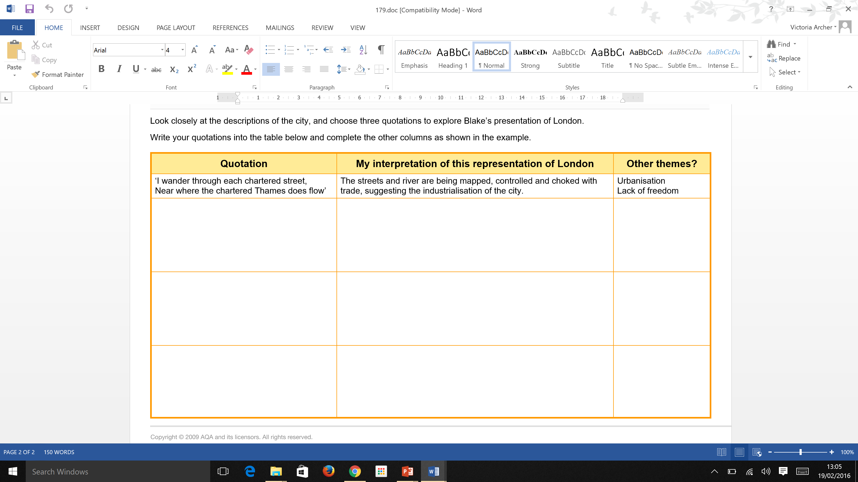

**Voice**: Who is speaking in the poem?

**Imagery:** What imagery is being created? How is it effective?

**Theme**: What are the main themes featured in the poem?

**Address**: Who is the poem addressed to? Why?

**Language** (Features): What type of language/ devices are used? What is their effect?

**Structure**: How is the poem laid out? What is the effect of this?

**William Wordsworth** was the stereotypical Romantic poet. He spent most of his life composing poetry as he walked around the Lake District. His poems are all about trying to restore the relationship between man and nature.

He was made Poet Laureate in 1843.

Had a close friendship with Samuel Taylor Coleridge who lived with Wordsworth and his sister Dorothy for two years. Both Coleridge and Dorothy were talented poets but dedicated their time and efforts to helping Wordsworth. The *Prelude* was dedicated to Coleridge.

**Romanticism** was a school of thinking which believed in restoring the balance between man and nature. They believed that emotion was a key element to poetry.

The power and serenity of nature were important elements to the early romantic poets.

They believed that the people who lived in the country, particularly children, had the best appreciation for nature. Many of them wrote about the social injustice of the condition of the common people.

Three key ideas: **revolution, nature and transcendence**

***The Prelude***was completed in 1805 but was intended to be part of a three-part poem called *The Recluse* which was never completed. *The Prelude* was published in 1850 by Wordsworth’s widow.

This extract comes from **Book I: Childhood and school time**.

**Where is the link to power or conflict in this poem?**

**FORM**

It is written **in blank verse**. This means verse with a regular metre but not rhyme. This was usually iambic pentameter (five iambs *– or unstressed/ stressed syllable pairs)*.

Why has this form been chosen?

**LANGUAGE**

Do you feel the language is easy to understand?

Can you identify any semantic fields (words linked to a common idea or theme)?

What techniques are being used?

**IMAGERY**

There is a change in the imagery in this poem between the beginning and end. What is the shift and effect does it have?

Can you define the images in this poem as either masculine or feminine?

**RHYTHM/RHYME**

Can you see any link between the language and rhythm and some of the action within the poem?

Why do you think Wordsworth made the choice to not use a rhyme scheme?

**TONES AND THEMES**

What is the mood at the beginning of the poem?

How has the mood changed by the end of the poem?

How do you as a reader feel about Wordsworth’s actions?

How do feel about the way the theme of nature is expressed in this poem?

**QUESTIONS ….more of them!**

Why do you think Wordsworth refers to the boat as ‘her’?

Explain how in lines 9-11 (‘small circles…) Wordsworth uses **verbs** and **adjectives** to portray the beauty of the lake.

Select an **adjective** that shows how Wordsworth initially felt as he rowed out in the stolen boat.

Explain which **words** show Wordsworth’s determination.

Select an **adverb** that conveys Wordsworth’s passion for rowing out and a **verb** that conveys his strength. Explain what might be giving him the strength.

A **volta** is a turning point. Which **phrase** best signifies the **volta** in terms of description? Explain what the **adjectives** in this phrase suggest about the mountain peak.

What **image** does Wordsworth’s use of **personification** convey about the peak?

How does the **verb** ‘towered’ strengthen this image?

Select a **simile** and explain how it reinforces this image.

Select **adjectives** that portray what effect this image of this peak had on Wordsworth.

Select a **phrase** that shows the prolonged effect the image of this peak had on Wordsworth.

Overall, what do you think Wordsworth is saying about the power of nature?

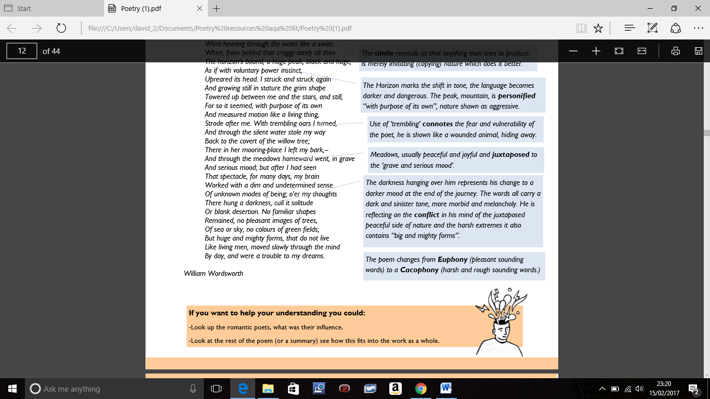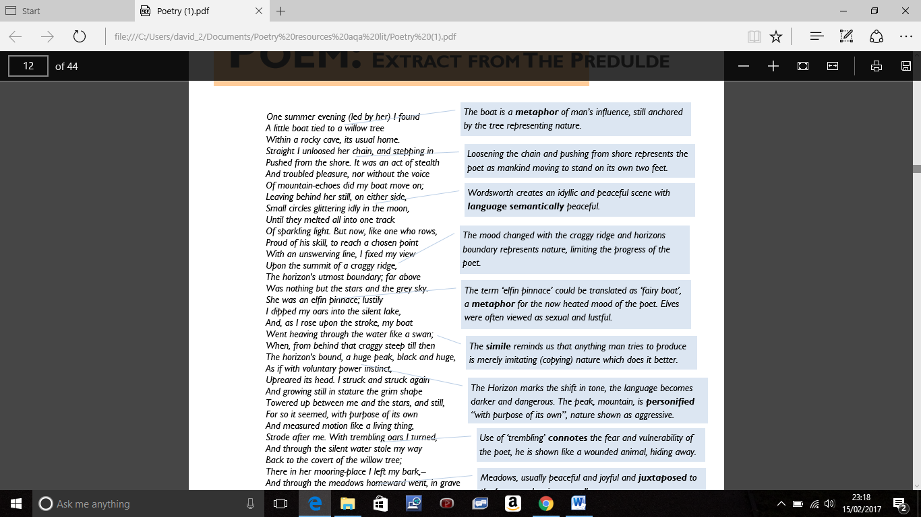

Glossary:

Pinnace – small boat

Lustily – with vigour/ effort

Covert - secret

Modes – types/ examples

**Numinous** (adjective)

If something is numinous it ‘arouses spiritual or religious emotion’ or is ‘mysterious or awe-inspiring.’

Can you incorporate this into your response?

**Onomatopoeia**

Words that sound like their meaning. E.g. “solutions **slop** in trays” (War Photographer); “the flickering gunnery **rumbles”** (Exposure)

**The effect** – The senses help us imagine the scene and put us in the poem: this helps us empathise with the individuals in the poem and understand what they are feeling.

**Similes**

When something or someone is described using ‘like’ or ‘as’. E.g. “a yellow hare that rolled like a flame” (Bayonet Charge); “the little fishing boats/ strung out like bunting” (Kamikaze)

**The effect -** 4 grade: Similes help us better imagine what is being described by giving us a fuller picture.

7 grade – Similes associate what is being described with other people/objects, and the associated connotations e.g. we get the sense that the hare is in danger, but “flame” reminds us of fire, and the poetic voice is being fired at; the “bunting” creates a contrasts with the patriotic flags of war.

**Metaphor**

When something or someone is described as **being** something else. E.g. “spools of suffering” (War Photographer); “All my words/ flattened, rolled, turned into felt” (Poppies)

**The effect -** 4 grade: Metaphors help us better imagine what is being described by giving us a fuller picture.

7 grade – Metaphors associate what is being described with other people/objects, and the associated connotations e.g. The photographs are a record of pain; the poetic voice’s words become soft – like “felt” – but also fuzzy, almost as if she can feel them.

**Personification**

When an object or idea is given human characteristics. E.g. “Dawn massing in the east her melancholy army” (Exposure); “Bullets smacking the belly out of the air” (Bayonet Charge)

**The effect** – Ideas such as love, time, triumph, disaster are **abstract** – hard for us to imagine; by using personification the poet makes these feelings seem alive and more real. It helps us to picture what the writer is talking about. When personification is used to make real objects seem alive, it adds a sense of magic or horror to the poet.

**Pronouns**

I, you, thee, he, she, we, they – these are all pronouns. E.g. “**I** met a traveller from an antique land” (Ozymandias); “turned into **your** skin” (Tissue); “Will’t please **you** sit and look at her?” (My Last Duchess) “**We** are prepared” (Storm on the island); “

**The effect –** When ‘**I/we**’ is used this makes us become the poet when we read it, especially if we read it aloud. This helps us see things from his/her point of view and better understand his/her feelings. When ‘**you’** is used, it makes us feel like the poet is talking directly to us: the writer is trying to persuade us of something. When ‘**she/he/they’** is used we feel like we are observing, we are there watching – this puts distance between us and the people in the poem, creating interest and intrigue.

**Literary techniques and their effects**

It is **NOT** important you can say what technique is being used – you get most marks for explaining the effect. So, if you spot effective language or imagery – but can’t say what technique it is – don’t worry. As long as you can explain the effect you will get marks.

That said, here are some common techniques…

**Sensory description**

Things we see, hear, smell, touch and feel.

e.g. “volley’d and thunder’d” (The Charge of the Light Brigade); “in raw-seamed hot khaki, his sweat heavy” (Bayonet Charge); “It tastes of sunlight” (The Émigree);

**The effect** – The senses help us imagine the scene and put us in the poem: this helps us empathise with the individuals in the poem and understand what they are feeling.

**Alliteration**

Two or more words that begin with the same sound (often the same letter but not always).

e.g. “measured motion” (The Prelude) “flowing flakes that flock” (Exposure)

**The effect** –

4 grade comment: The alliteration draws our attention to key words, helping the writer make their feelings clear.

7 grade comment: The repetition of sounds creates an **onomatopoeic** effect, which appeals to our sense of sound, helping us imagine more clearly what is being described.

**Sibilance**

A concentration of ‘s’ sounds, also produced by the letters ‘z’, ‘x’ and sometimes ‘c’.

e.g. “Worried by silence, sentries whisper, curious, nervous “  (Exposure); “Solutions slop in trays

beneath his hands” (War Photographer)

**The effect –**

4 grade comment: The sibilance creates a sinister tone, like hissing snake, which puts the reader on edge.

7 grade comment: The repetition of ’s’ sounds creates an **onomatopoeic** effect, which appeals to our sense of sound, helping us imagine more clearly what is being described, be it the wind or waves on the sea shore, or the personality of the speaker.

**Repetition**

Words, phrases or whole sentences that get repeated. e.g. “Half a league, half a league, half a league” (The Charge of the Light Brigade); “Dem tell me” (Checking out me history);

**The effect** –

4 grade comment: The repetition draws our attention to key words, helping the writer make their feelings clear.

7 grade comment: Regular repetition of creates **rhythm**, which helps make the poem memorable so the writer’s message sticks in our minds and the poem continues to speak to us long after we’ve read it.

**Rhyme**

Words that have a similar sound – note these words don’t have to come at the end of line

**The effect** –

·Very little rhyme – this draws our attention to key words, helping the writer make their feelings clear.

·Regular rhyme of creates **rhythm**, which helps make the poem memorable so the writer’s message sticks in our minds and the poem continues to speak to us long after we’ve read it. (e.g. My Last Duchess, Ozymandias)

·Half-rhymes have a similar effect to sibilance: they put us on edge (e.g. Exposure)

**The Prelude**

One summer evening (led by her) I found  
A little boat tied to a willow tree  
Within a rocky cave, its usual home.  
Straight I unloosed her chain, and stepping in  
Pushed from the shore. It was an act of stealth  
And troubled pleasure, nor without the voice  
Of mountain-echoes did my boat move on;  
Leaving behind her still, on either side,  
Small circles glittering idly in the moon,  
Until they melted all into one track  
Of sparkling light. But now, like one who rows,  
Proud of his skill, to reach a chosen point  
With an unswerving line, I fixed my view  
Upon the summit of a craggy ridge,  
The horizon’s utmost boundary; far above  
Was nothing but the stars and the grey sky.  
She was an elfin pinnace lustily  
I dipped my oars into the silent lake,  
And, as I rose upon the stroke, my boat  
Went heaving through the water like a swan;  
When, from behind that craggy steep till then  
The horizon’s bound, a huge peak, black and huge,  
As if with voluntary power instinct,  
Upreared its head. I struck and struck again,  
And growing still in stature the grim shape  
Towered up between me and the stars, and still,  
For so it seemed, with purpose of its own  
And measured motion like a living thing,  
Strode after me. With trembling oars I turned,  
And through the silent water stole my way  
Back to the covert of the willow tree;  
There in her mooring-place I left my bark,–  
And through the meadows homeward went, in grave  
And serious mood; but after I had seen  
That spectacle, for many days, my brain  
Worked with a dim and undetermined sense  
Of unknown modes of being; o’er my thoughts  
There hung a darkness, call it solitude  
Or blank desertion. No familiar shapes  
Remained, no pleasant images of trees,  
Of sea or sky, no colours of green fields;  
But huge and mighty forms, that do not live  
Like living men, moved slowly through the mind  
By day, and were a trouble to my dreams.

William Wordsworth 1805

**My Last Duchess Robert Browning**

***A Dramatic Monologue***

***Rule –*** These poems are *dramatic* in the sense that they have a theatrical quality; that is, the poem is meant to be read to an audience. This means the poem is written in the **voice** of a character, a male narrator - an imaginary Italian Duke.

Most of the time, the speaker is trying to convince someone of something, and may or may not be telling the whole truth.

**When trying to understand a dramatic monologue, ask yourself these questions:**

What is the situation?

Who is the speaker talking to and why?

What tactics is the speaker using to make his case?

Does the speaker seem to change his mind during the poem?

What do *you* think about this character and what he has to say?

The characters mentioned in this poem are based on real life, historical figures. The narrator is **Duke Alfonso II** who ruled a place in northern Italy called Ferrara between 1559 and 1597. The Duchess of whom he speaks was his first wife, **Lucrezia de' Medici** who died in 1561 aged 17, only two years after he married her. In real life, Lucrezia died in suspicious circumstances and might have been poisoned.

The poem is set in 1564, three years after the death of the Duchess. An emissary (messenger or representative) has been sent to see the Duke from the Count of Tyrol. The Count is the father of the Duke's next wife (he married three times in all). The Duke shows the emissary a picture of his late wife and remarks on her character, suggesting that she was unfaithful to him - and hinting that he might have killed her because of it.

During his speech, the Duke makes himself look arrogant, insensitive and selfish.

**My Last Duchess**

That’s my last Duchess painted on the wall,

Looking as if she were alive. I call

That piece a wonder, now; Fra Pandolf’s hands

Worked busily a day, and there she stands.

Will’t please you sit and look at her? I said

“Fra Pandolf” by design, for never read

Strangers like you that pictured countenance,

The depth and passion of its earnest glance,

But to myself they turned (since none puts by

The curtain I have drawn for you, but I)

And seemed as they would ask me, if they durst,

How such a glance came there; so, not the first

Are you to turn and ask thus. Sir, ’twas not

Her husband’s presence only, called that spot

Of joy into the Duchess’ cheek; perhaps

Fra Pandolf chanced to say, “Her mantle laps

Over my lady’s wrist too much,” or “Paint

Must never hope to reproduce the faint

Half-flush that dies along her throat.” Such stuff

Was courtesy, she thought, and cause enough

For calling up that spot of joy. She had

A heart—how shall I say?— too soon made glad,

Too easily impressed; she liked whate’er

She looked on, and her looks went everywhere.

Sir, ’twas all one! My favour at her breast,

The dropping of the daylight in the West,

The bough of cherries some officious fool

Broke in the orchard for her, the white mule

She rode with round the terrace—all and each

Would draw from her alike the approving speech,

Or blush, at least. She thanked men—good! but thanked

Somehow—I know not how—as if she ranked

My gift of a nine-hundred-years-old name

With anybody’s gift. Who’d stoop to blame

This sort of trifling? Even had you skill

In speech—which I have not—to make your will

Quite clear to such an one, and say, “Just this

Or that in you disgusts me; here you miss,

Or there exceed the mark”—and if she let

Herself be lessoned so, nor plainly set

Her wits to yours, forsooth, and made excuse—

E’en then would be some stooping; and I choose

Never to stoop. Oh, sir, she smiled, no doubt,

Whene’er I passed her; but who passed without

Much the same smile? This grew; I gave commands;

Then all smiles stopped together. There she stands

As if alive. Will’t please you rise? We’ll meet

The company below, then. I repeat,

The Count your master’s known munificence

Is ample warrant that no just pretense

Of mine for dowry will be disallowed;

Though his fair daughter’s self, as I avowed

At starting, is my object. Nay, we’ll go

Together down, sir. Notice Neptune, though,

Taming a sea-horse, thought a rarity,

Which Claus of Innsbruck cast in bronze for me!

Robert Browning (1812-1889)

**Did you know?**

* The poem is written in **iambic pentameter.** This means that there are five feet in each line. Each foot contains two syllables. -
* Traditionally, iambic pentameter is written in the following pattern of **unstressed** and **stressed** syllables.
* Iambic pentameter often follows the **natural rhythm of speech**, a little like a **heartbeat.** If we apply this to pattern to Browning’s opening line, it would be as follows.

*That’s* ***my*** *last* ***duch****ess* ***paint****ed* ***on*** *the* ***wall***

🗩 Try reading it aloud a few times, sticking closely to the pattern of unstressed and stressed syllables as marked above.

❓ Does the above **rhythm sound natural**? Does it seem to capture the **meaning** of the words in the line?

**Storm on the Island**

We are prepared: we build our houses squat,

Sink walls in rock and roof them with good slate.

The wizened earth had never troubled us

With hay, so as you can see, there are no stacks

Or stooks that can be lost. Nor are there trees

Which might prove company when it blows full

Blast: you know what I mean - leaves and branches

Can raise a chorus in a gale

So that you can listen to the thing you fear

Forgetting that it pummels your house too.

But there are no trees, no natural shelter.

You might think that the sea is company,

Exploding comfortably down on the cliffs

But no: when it begins, the flung spray hits

The very windows, spits like a tame cat

Turned savage. We just sit tight while wind dives

And strafes invisibly. Space is a salvo.

We are bombarded by the empty air.

Strange, it is a huge nothing that we fear.

**Seamus Heaney**

wizened (line 3)  - dried up, shrivelled

* stacks / stooks (lines 4/5)- haystacks / shocks of corn sheaves

·         strafes (line 17)- bombards, harasses with artillery shells

·         salvo (line 17) - simultaneous firing of artillery

1.    After reading the poem what do you think it is about?

2.    What have the islanders done to prepare for the storm? What else might suggest about their community?

3.    List as many details as you can about the island.

4.    Enjambment is when the meaning of one line flows into another. Pick two examples of this and describe what the effect is.

5.    When does this mood of the poem change from safety to fear? Justify your choice.

6.    The second half of the poem is full of violent imagery. Pick out some of these words.  What do these words show about the feelings of the islanders?

7.    The narrator speaks directly to the reader. Find an example and explain the effect of  doing this.

8.    Find an example of: alliteration, simile, metaphor and personification. For each example explain the effect.

9.    What do you think the last line shows us about the narrator’s feelings? Contrast it with the opening.

10. What is your response to the poem? What ideas about power and conflict does it give you?

**Lost Blast Tragic Pummels  Exploding Flung**

**Exposure**

Our brains ache, in the merciless iced east winds that knife us...  
Wearied we keep awake because the night is silent...  
Low drooping flares confuse our memory of the salient...  
Worried by silence, sentries whisper, curious, nervous,  
             But nothing happens.

Watching, we hear the mad gusts tugging on the wire.  
Like twitching agonies of men among its brambles.  
Northward incessantly, the flickering gunnery rumbles,  
Far off, like a dull rumour of some other war.  
             What are we doing here?

The poignant misery of dawn begins to grow...  
We only know war lasts, rain soaks, and clouds sag stormy.  
Dawn massing in the east her melancholy army  
Attacks once more in ranks on shivering ranks of gray,  
             But nothing happens.

Sudden successive flights of bullets streak the silence.  
Less deadly than the air that shudders black with snow,  
With sidelong flowing flakes that flock, pause and renew,  
We watch them wandering up and down the wind's nonchalance,  
             But nothing happens.

Pale flakes with lingering stealth come feeling for our faces -  
We cringe in holes, back on forgotten dreams, and stare, snow-dazed,  
Deep into grassier ditches. So we drowse, sun-dozed,  
Littered with blossoms trickling where the blackbird fusses.  
             Is it that we are dying?

Slowly our ghosts drag home: glimpsing the sunk fires glozed  
With crusted dark-red jewels; crickets jingle there;  
For hours the innocent mice rejoice: the house is theirs;  
Shutters and doors all closed: on us the doors are closed -  
             We turn back to our dying.

Since we believe not otherwise can kind fires burn;  
Now ever suns smile true on child, or field, or fruit.  
For God's invincible spring our love is made afraid;  
Therefore, not loath, we lie out here; therefore were born,  
             For love of God seems dying.

To-night, His frost will fasten on this mud and us,  
Shrivelling many hands and puckering foreheads crisp.  
The burying-party, picks and shovels in their shaking grasp,  
Pause over half-known faces. All their eyes are ice,  
             But nothing happens.

                                                                                                                                                                                                                 Wilfred Owen

Before we look at the poem, what does **exposure** (or exposed) mean?

Any ideas what the poem might be about?

*(Hint: The poet, Wilfred Owen, was a famous WW1 poet)*

***How would it feel to live, fight and die in these conditions?***

***Why do you think Owen chooses to include the weather in this poem?***

***Our brains ache, in the merciless iced east winds that knife us…”***

***Owen uses personification to give the wind the human characteristic of being “merciless”. In showing the wind as being “merciless” Owen is showing the weather to be another enemy or opponent for the soldiers to face. The use of the adjective, “iced” and verb, “knife” gives the reader the impression that the weather is physically attacking the soldiers, it makes the reader feel sympathy for the soldiers who are stuck in the trenches unable to escape the harsh conditions.***

***Owen starts the poem with “Our brains ache” this could be read literally, the soldiers have headaches caused by the cold winds. It could also refer to the physical and emotional pain the soldiers are experiencing as a result of being forced to fight in WW1.***

***Line by line:***

***1.Does your line use any poetic techniques?***

***2.What is the deeper meaning in your line?***

***3.What is the impact on the reader? (What does it make us think?)***

***4.Comment on the punctuation – how does this affect the reading of the poem (faster/slower – how does this link to the content?)***

Owen’s choice of words in *Exposure* powerfully, but simply, describes the extremes to which he and his men were exposed for two days. The poem is dominated by words from the [semantic field](http://crossref-it.info/repository/atoz/semantic-field) of the weather, most of which are qualified by terms with negative associations:

* ‘iced east winds’ l.1 ‘mad gusts’ l.6 ‘rain soaks’ l.12 ‘clouds sag stormy’ l.12
* ‘Dawn massing in the east’ l.13 ‘ranks of grey’ (cloud) l.14
* ‘air .. black with snow’ l.17
* ‘flowing flakes’ (snow) l.18 ‘the wind’s nonchalance’ l.19 ‘Pale flakes ‘ (snow) l.21
* ‘snow-dazed’ l.22 ‘frost’ l.36 ‘ice’ l.39

**The Charge of the Light Brigade**

Half a league, half a league,

Half a league onward,

All in the valley of Death

Rode the six hundred.

"Forward, the Light Brigade!

"Charge for the guns!" he said:

Into the valley of Death

Rode the six hundred.

"Forward, the Light Brigade!"

Was there a man dismay'd?

Not tho' the soldier knew

Someone had blunder'd:

Theirs not to make reply,

Theirs not to reason why,

Theirs but to do and die:

Into the valley of Death

Rode the six hundred.

Cannon to right of them,

Cannon to left of them,

Cannon in front of them

Volley'd and thunder'd;

Storm'd at with shot and shell,

Boldly they rode and well,

Into the jaws of Death,

Into the mouth of Hell

Rode the six hundred

Flash'd all their sabres bare,

Flash'd as they turn'd in air,

Sabring the gunners there,

Charging an army, while

All the world wonder'd:

Plunged in the battery-smoke

Right thro' the line they broke;

Cossack and Russian

Reel'd from the sabre stroke

Shatter'd and sunder'd.

Then they rode back, but not

Not the six hundred.

Cannon to right of them,

Cannon to left of them,

Cannon behind them

Volley'd and thunder'd;

Storm'd at with shot and shell,

While horse and hero fell,

They that had fought so well

Came thro' the jaws of Death

Back from the mouth of Hell,

All that was left of them,

Left of six hundred.

When can their glory fade?

O the wild charge they made!

All the world wondered.

Honor the charge they made,

Honor the Light Brigade,

Noble six hundred.

**Journalist W.H.Russell reported on the Charge in The Times:**

At the minutes past eleven our Light Cavalry Brigade advanced…They swept proudly past, glittering in the morning sun in all the pride and splendour of war…At the distance of 1200 yards the whole line of the enemy belched forth, from thirty iron mouths, a flood of smoke and flame. The flight was marked by instant gaps in our ranks, by dead men and horse, by steeds flying and wounded or rider less across the plain…They flew into the smoke of the batteries; but before they were lost from view the plain was strewn with their bodies. Through the clouds of smoke we could see their sabres flashing as they rode between the guns, cutting down the gunners as they stood… The flank fire of the batteries on the hill swept them down…at thirty five minutes past eleven not a British soldier, except the dead and the dying, was left in front of the Russian guns.

What is suggested by the imagery in the following phrases?

•‘the valley of Death’

•‘the mouth of Hell’

•‘volley’d and thunder’d’

•‘storm’d at with shot and shell’

•‘while horse and hero fell’

What emotion does each quote convey?

How does the repetition support the theme of conflict within the poem?

The poem is very regular in its structure, with several examples of repetition. ‘The Charge of the Light

Brigade’ is a narrative poem - each of the stanzas progress the story of the failed attack.

**Contextual background**

* *It’s the 1850s; Great Britain is at war with Russia…*
* *Tennyson* wrote "The Charge of the Light Brigade" in a few minutes on December 2, 1854. He had read an article in the London Times about the Battle of Balaclava in the *Crimean* War (the ‘Crimea’ modern day Ukraine), which was fought from 1853 to 1856.
* On 25 October 1854 British C-in-C, Lord Raglan, decided to attack the *Russians*. He sent an order but it was fatally misinterpreted, and 673 Light Brigade cavalrymen were sent charging down the *valley* with Russian guns and units on 3 sides... Between 100 and 200 soldiers are thought to have *died.*
* Raglan's order was *badly* written. It told cavalry commander Lord Lucan "to go quickly to the front... & try to stop the enemy carrying away the guns". The order was *delivered* by his aide, Captain Nolan, and Lucan asked Nolan what it exactly meant. Nolan impatiently pointed down the valley and replied: "There, my Lord, is your enemy; there are your *guns*." Captain Nolan was killed moments later during the ill-fated charge.
* The whole torrid affair lasted no more than 20 minutes!
* This poem is about *courage*, not about the bad luck or stupidity that put the men of the Light Brigade cavalry in a position to show that courage.85

**Bayonet Charge by Ted Hughes**

**Background**

‘When I ﬁrst started writing,’ Ted Hughes acknowledged, ‘I wrote again and again and again about the First World War.’ He ascribed that compulsion to three factors: the stories told by his father, who had survived his regiment’s massacre at Gallipoli; a love of Wilfred Owen’s poetry; and the West Yorkshire landscape where he grew up believing that ‘the whole region is in mourning for the ﬁrst world war’. Despite his best efforts, Hughes never managed to free himself from his subject. As a child, he also gained an interest in the natural world and the violence required to survive in harsh environments.

“It is occasionally possible, just for brief moments, to find the words that will unlock the doors of all those many mansions inside the head and express something — perhaps not much, just something — of the crush of information that presses in on us from the way a crow flies over and the way a man walks and the look of a street and from what we did one day a dozen years ago. Words that will express something of the deep complexity that makes us precisely the way we are, from the momentary effect of the barometer to the force that created men distinct from trees… and in that same moment, make out of it all the vital signature of a human being — not of an atom, or of a geometrical diagram, or of a heap of lenses — but a human being, we call it poetry.” Hughes.

**Bayonet Charge**

Suddenly he awoke and was running - raw

In raw-seamed hot khaki, his sweat heavy,

Stumbling across a field of clods towards a green hedge

That dazzled with rifle fire, hearing

Bullets smacking the belly out of the air -

He lugged a rifle numb as a smashed arm;

The patriotic tear that had brimmed in his eye

Sweating like molten iron from the centre of his chest, -

In bewilderment then he almost stopped –

In what cold clockwork of the stars and the nations

Was he the hand pointing that second? He was running

Like a man who has jumped up in the dark and runs

Listening between his footfalls for the reason

Of his still running, and his foot hung like

Statuary in mid-stride. Then the shot-slashed furrows

Threw up a yellow hare that rolled like a flame

And crawled in a threshing circle, its mouth wide

Open silent, its eyes standing out.

He plunged past with his bayonet toward the green hedge,

King, honour, human dignity, etcetera

Dropped like luxuries in a yelling alarm

To get out of that blue crackling air

His terror’s touchy dynamite.

**TED HUGHES**

**Language Techniques... What are they and what is their effect?**

**His terror's touchy dynamite L23**

**Lugged a rifle as numb as a smashed arm L6**

**Bullets smacking the belly L5**

**In what cold clockwork of the stars L10**

**onomatopoeia simile metaphor alliteration**

**Interpreting the text**

* How does the soldier feel as he wakes?

* What physical state is he in?

* What does he think as he hears the bullets?

* What happened to the tear in his eye? Why?

* What makes him hesitate and nearly stop?

* What is he thinking about at this point?

* How has instinct taken over? Interpreting the text:

* Why does he notice the hare?

* What does it make him think about?

* What does he think as he charges?

* Why does he scream?

**The final four lines**

King, honour, human dignity, etcetera

Dropped like luxuries in a yelling alarm

To get out of that blue crackling air

His terror's touchy dynamite

**Reflection... \*** Why does he say king, honour and human dignity are 'luxuries'? **\*** Is the use of 'etcetera' important? **\*** What is suggested in the last line? Explain your ideas.

**Poppies by Jane Weir**

**Background**

Jane Weir is an Anglo-Italian writer, designer and editor who grew up in Manchester and Northern Italy. She lived in Belfast for several years before moving back to England. 'Poppies' was published in the selection of contemporary war poetry commissioned by Carol Ann Duffy for the Guardian in July 2009. She calls 'Poppies' a contemporary war poem about war in its various guises.

"I wanted to write a poem from the point of view of a mother and her relationship with her son, a child who was loved cherished and protected… and it had led to this…. heightened and absolute fear that parents experience in letting their children go, the anxiety and ultimately the pain of loss… I hoped to somehow channel all this, convey it into something concise and contemporary, but also historically classic, in terms of universal experience." **Jane Weir**

Poets, from ancient times, have written about war. It is the poet's obligation, wrote Plato, to bear witness. In modern times, the young soldiers of the first world war turned the horrors they endured and witnessed in trench combat - which slaughtered them in their millions - into a vividly new kind of poetry, and most of us, when we think of "war poetry" will find the names of Wilfred Owen and Siegfried Sassoon coming first to our lips, with Ivor Gurney, Isaac Rosenberg, Rupert Brooke ... What passing-bells for these who die as cattle? ... There's some corner of a foreign field ... Such lines are part of the English poetry reader's DNA, injected during schooldays like a vaccine.

British poets in our early 21st century do not go to war. War, it seems, makes poets of soldiers and not the other way round. Today, as most of us do, poets largely experience war - wherever it rages - through emails or texts from friends or colleagues in war zones, through radio or newsprint or television, through blogs or tweets or interviews. With the official inquiry into Iraq imminent and the war in Afghanistan returning dead teenagers to the streets of Wootton Bassett, I invited a range of my fellow poets to bear witness, each in their own way, to these matters of war.

**Carol Ann Duffy (Poet Laureate)**

**How does Jane Weir bear witness?**

**Poppies**

Three days before Armistice Sunday

and poppies had already been placed

on individual war graves. Before you left,

I pinned one onto your lapel, crimped petals,

spasms of paper red, disrupting a blockade

of yellow bias binding around your blazer.

Sellotape bandaged around my hand,

I rounded up as many white cat hairs

as I could, smoothed down your shirt’s

upturned collar, steeled the softening

of my face. I wanted to graze my nose

across the tip of your nose, play at

being Eskimos like we did when

you were little. I resisted the impulse

to run my fingers through the gelled

blackthorns of your hair. All my words

flattened, rolled, turned into felt,

slowly melting. I was brave, as I walked

with you, to the front door, threw

it open, the world overflowing

like a treasure chest. A split second

and you were away, intoxicated.

After you’d gone I went into your bedroom,

released a song bird from its cage.

Later a single dove flew from the pear tree,

and this is where it has led me,

skirting the church yard walls, my stomach busy

making tucks, darts, pleats, hat-less, without

a winter coat or reinforcements of scarf, gloves.

On reaching the top of the hill I traced

the inscriptions on the war memorial,

leaned against it like a wishbone.

The dove pulled freely against the sky,

an ornamental stitch. I listened, hoping to hear

your playground voice catching on the wind.

**JANE WEIR**

**Poppies – thoughts, techniques and questions**

**What is the role of women during times of conflict?**

**Consider how the poet makes use of gender stereotypes within her poem.**

Felt Making - **a motif ( theme, idea, pattern, decoration)**

‘I applied the technique of felt making to this poem because it seemed apt to the process of grief. The slow remembrance of layering, the thick wadding, which over time creates a density that’s almost impenetrable, the muffled deadness of the texture of felt and its ability to denote dumbness, padding and the impossibility of the open expression of grief, how the felt merges and melts, and how if one is to grieve one has to, at some point, allow this to dissolve. And the poem does this; it breaks when the mother goes into her son’s empty bedroom.’ **Weir**

**What is the importance of this motif?**

**Interpreting the text**

**Clothing and textile language** * Find all the references to clothing. * Why are they used? What are the associations?

**Sensory details** * What sensory details are there in stanza 2? * Why are they used? What connotations do they have?

**Verbs** * Track the verbs used throughout the poem. * What do you notice? How do they help to reveal different emotions?

**The final three lines**

The dove pulled freely against the sky,

an ornamental stitch. I listened, hoping to hear

your playground voice catching on the wind.

**Reflection**... * Why does the poet refer to the dove? **\*** How is Weir making use of perspective? Explain your ideas.

**Further questions**

1. Is the poem about war or a poem about families?

2. How does the title refer to the poem?

3. Why does the mother have so many feelings of anxiety and fear?

4. Why does the poet use the metaphor of a bird?

5. Do you think the son is still alive? Explain.

**Tissue by Imtiaz Dharker**

**Background**

If there were to be a World Laureate, then for me the role could only be filled by Imtiaz Dharker.’ Carol Ann Duffy

Poet, artist and documentary film-maker.

Born in Pakistan, raised in Scotland

Now lives between London, Wales and Mumbai.

Describes herself as “Scottish Muslim Calvinist" adopted by India and married into Wales.

Married twice. Second husband died after a long battle with cancer

Themes, concerns and interests in her work include: freedom, journeys, geographical and cultural displacement, communal conflict, gender politics, shelter, education and health for women and children.

**In summary, the poem is about the poet’s idea that…**

The world would be a better place if it had more in common with ‘tissue’ – nothing is supposed to last so we should let things go more.

The world has some big problems: destruction, war, politics, money, wealth, terrorism. We have built the world around these things.

The world also has some hope.

People need to ‘let go’ of small, insignificant issues

It is: SYMBOLIC, IMPRESSIONISTIC, ATMOSPHERIC, EMOTIONAL

**Paper is important, but fragile… like life itself.**

**Links the ideas of buildings being made from paper to human skin.**

**Purposefully complex and strange ideas. Reader’s response is as important as the writer’s thoughts.**

**Structure**

Quatrains: Regular and square, like paper

Unrhymed and irregular rhythm: random flow of life

**Language**

Paper is used symbolically as one long EXTENDED METAPHOR.

**Tissue – questions, thoughts and techniques**

How many different things do you use paper for in an average day? Come up with another list of all its uses. What can you do with the piece of paper in front of you?

Why is paper important? What could paper symbolise or represent?

What connotations does the word ‘Tissue’ have?

**Language, Form and Structure**

Maps, kite, road, paper, daylight, drift, brick, script. **What connotations do these words have?**

Who is narrating the poem?

How does the narrator seem to feel?

How is the poem structured?

What might the poem’s structure represent?

Is there any use of rhyme? Why? Why not?

Why do you think the poet lists details of what families might write in the back of the Koran?

Why does Dharker describe the human body as a ‘structure’?

Why do you think the architect would ‘never wish to build again with brick ?

The word ‘transparent’ is repeated. Why do you think this is?

**Themes**

Power Instability What it means to be human Religion

**TASK**: Find at least one quote which relates to each of these themes.

**CHALLENGE: Can you use subject terminology to analyse your quotes? Find quotes which have an interesting language technique which you can identify.**

The poem is written in free verse: unrhymed, irregular quatrains. Lots of **enjambment**. Why? What is different about the last stanza? Why?

Look for examples of **lists, rule of 3, alliteration and sibilance**. Why are these **techniques** used? Look for adjectives about delicacy.

Look for a **semantic field of light**. What could this represent?

**Tissue**

Paper that lets the light

shine through, this

is what could alter things.

Paper thinned by age or touching,

the kind you find in well-used books,

the back of the Koran, where a hand

has written in the names and histories,

who was born to whom,

the height and weight, who

died where and how, on which sepia date,

pages smoothed and stroked and turned

transparent with attention.

If buildings were paper, I might

feel their drift, see how easily

they fall away on a sigh, a shift

in the direction of the wind.

Maps too. The sun shines through

their borderlines, the marks

that rivers make, roads,

railtracks, mountainfolds,

Fine slips from grocery shops

that say how much was sold

and what was paid by credit card

might fly our lives like paper kites.

An architect could use all this,

place layer over layer, luminous

script over numbers over line,

and never wish to build again with brick

or block, but let the daylight break

through capitals and monoliths,

through the shapes that pride can make,

find a way to trace a grand design

with living tissue, raise a structure

never meant to last,

of paper smoothed and stroked

and thinned to be transparent,

turned into your skin.

**Imtiaz Dharker**